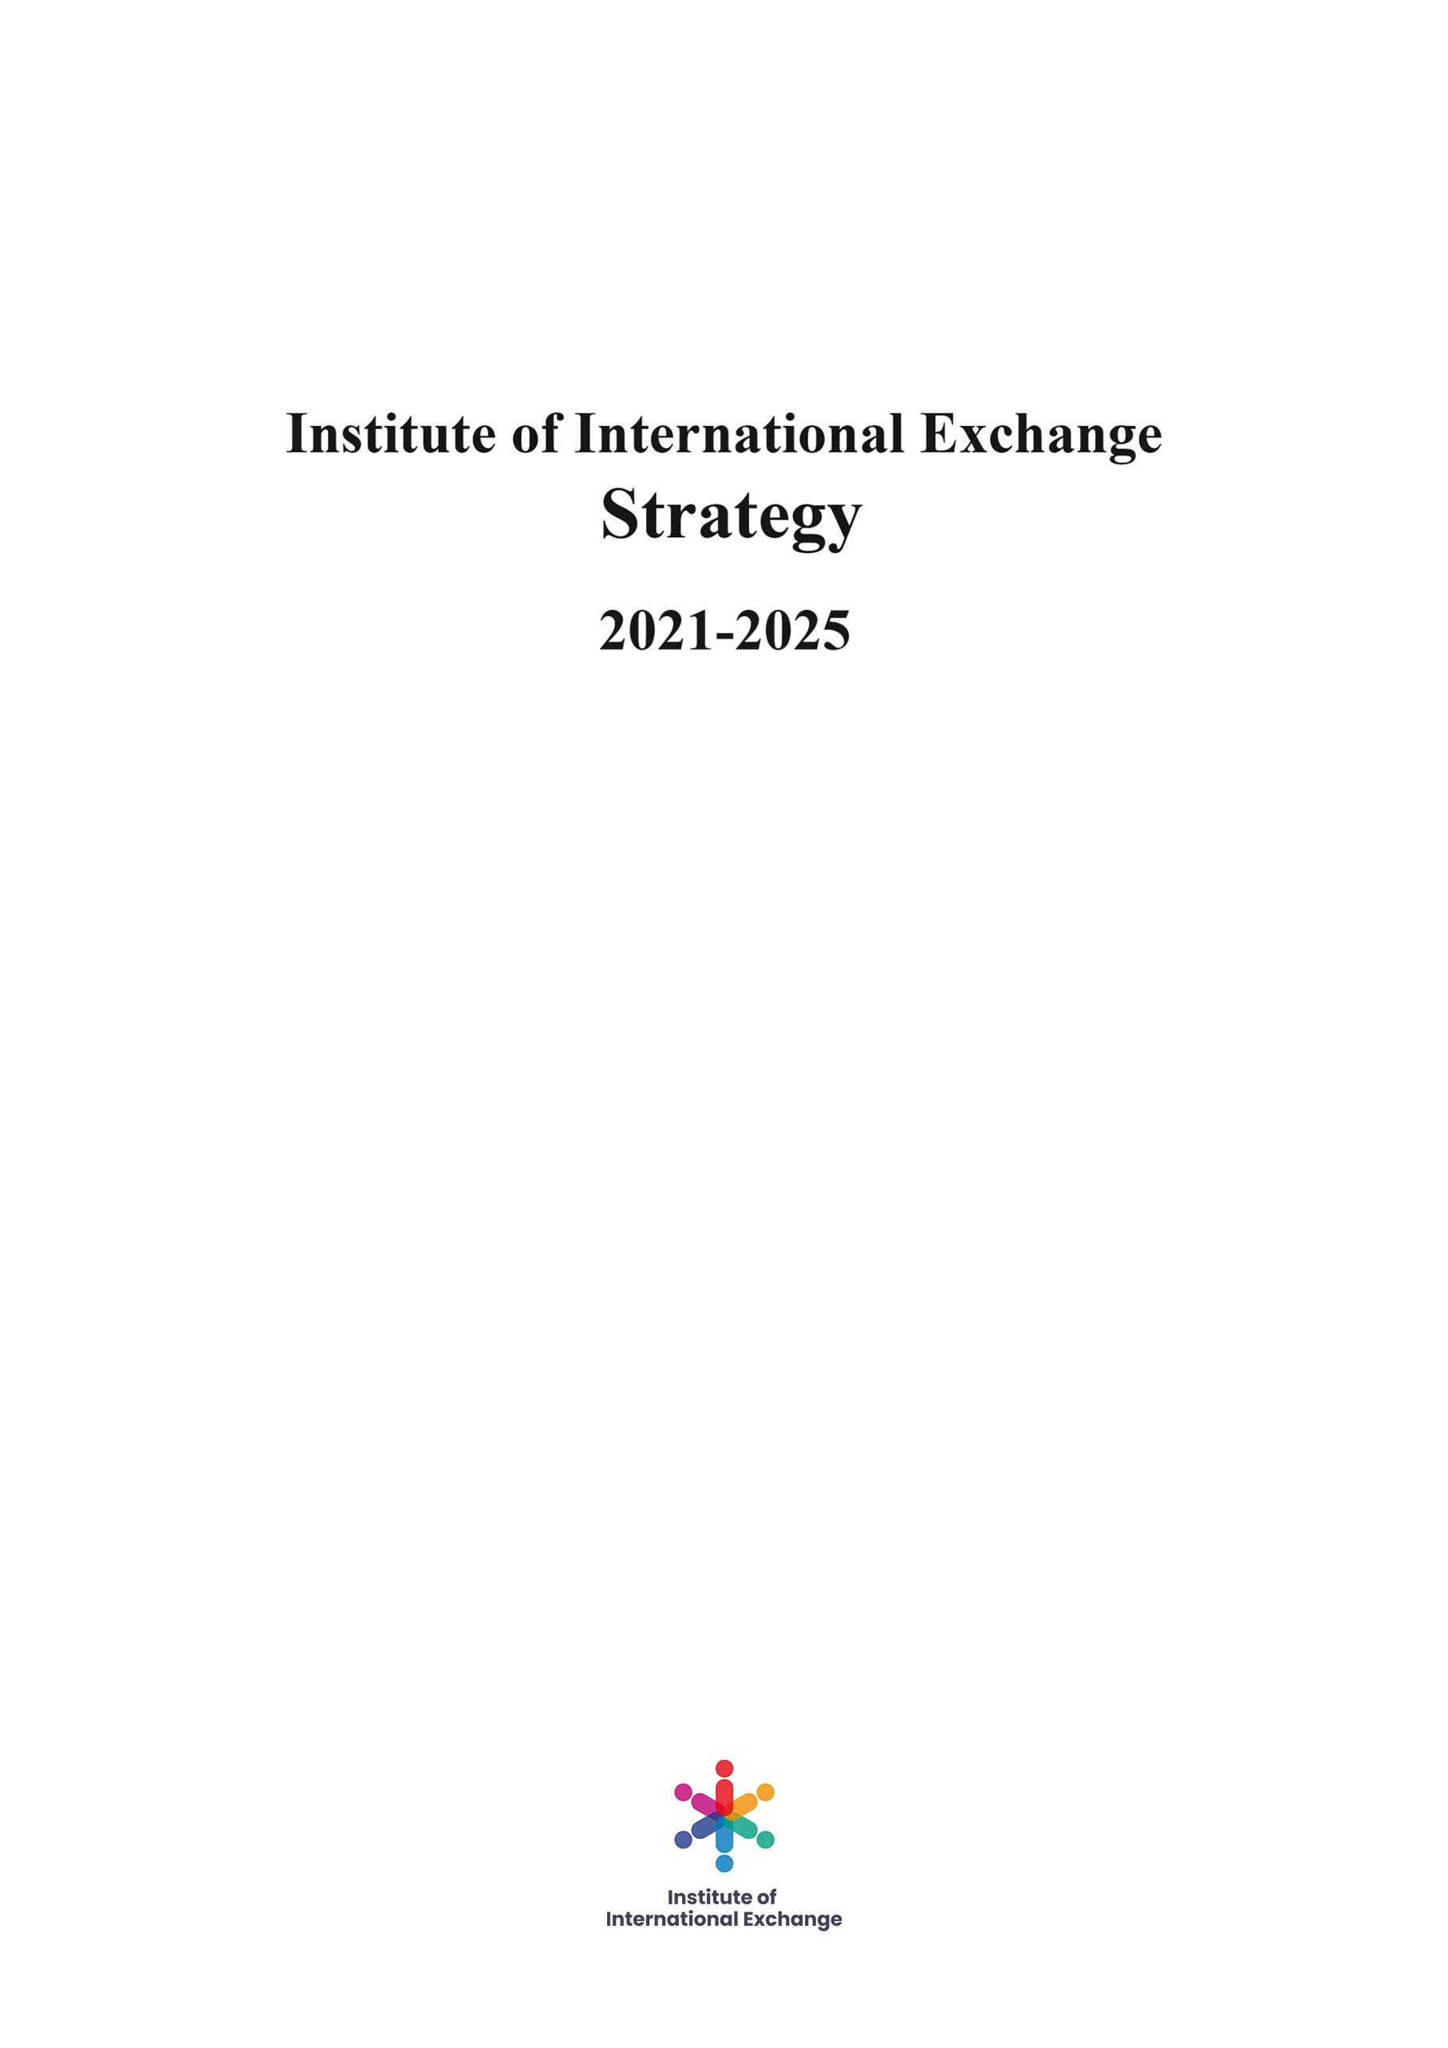

I. Starting Point
Promoting International Exchanges and Cooperation
All the work of IIE, including Research Programs, Exchange Plans, Initiative X and other formal programs, fundamentally starts with promoting international exchanges and cooperation. If the original intention of any program is set against the starting points, it won’t be officially approved and engaged in by IIE. We believe that wider international exchanges and cooperation is the right and inevitable direction for the development of human society, which is not only the well-being of all mankind, but also the principle of basic value that IIE adheres to. Our desire is to help and prepare the younger generation for becoming leaders of tomorrow and to also teach them the win-win cooperation between all nations.

II. Basis of Exchange:
Friendship, Equality, Objectivity and Neutrality
Within relevant international laws and the related criterion and resolutions framework of the United Nations, IIE adheres to the fundamental principles of friendship, equality, objectivity and neutrality for all members, partners and other interested parties. We respect mutually and treat each other in integrity without any prejudice, and will always maintain the attitude of exchange and learning, opening-up and cooperation and innovation. We hope that our members and partners will also use these principles as a basis for cooperation.

III. Comply with laws and regulations
IIE will strictly comply with relevant international laws, the relevant regulations of the United Nations and laws and administrative regulations of the concerning countries or regions. We are committed to promoting international exchanges and cooperation, and compliance with laws and regulations is the bottom line of IIE’s behavior.

IV. Uninvolved with political, military and other sensitive issues
IIE’s work covers many fields such as economy, culture, education, social development, energy and environment. However, we would not participate in politics and military fields. IIE does not hold any political position and will not participate in any activities related to war and military confrontation. We adhere to objectivity and neutrality all the time, and do not engage in any form of ideological struggle, disagreement, extreme religious activities and terrorism, etc.

V. Non-profit
IIE insists on being non-profit. All IIE’s income, including funds or any other form of income, will be used to support the daily operation of various work, employees’ salary and welfare and IIE’s own development. We will disclose relevant financial reports and other information in accordance with the laws, regulations and requirements of relevant countries or regions and program funding entities.

VI. Pursuit of Excellence
IIE always pursues the excellence in work and strives to make every work participated by IIE excellent. We spare no effort to improve ourselves in work, hold a positive learning attitude at all times, and constantly make breakthroughs to benefit our members, partners and other interested parties. We keep our values up high and we will present them to all our members and partners. Our desire is to encourage people to explore their diversity in a unified world, with accents on learning, kindness, empathy and adaptability to an ever-changing world.

