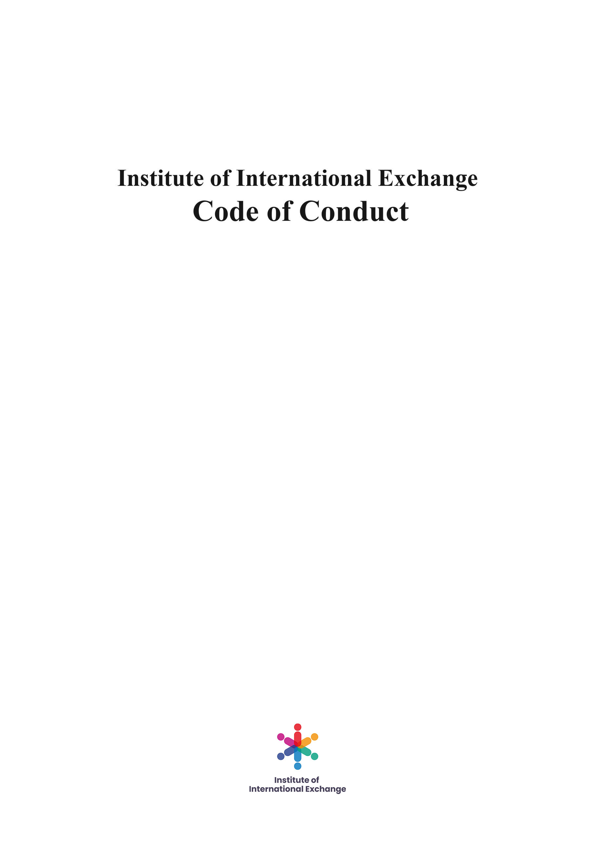

Ⅰ. About Us

The Institute of International Exchange (IIE) is a non–governmental and non–profit international organization. We hope to build an equal and friendly platform for exchanges and cooperation around the world.

We participate in and advocate the importance of exchanges in today’s society, including but not limited to the economy, education, energy and sustainable development, culture and arts, social security and many other fields. We promote the all-round development of global communication through various studies and conferences.

We focus on the professional development of our members and provide them with international support and projects, so that more people can participate in the organization and strive for the common welfare of human society.

- Aim
The Institute of International Exchange (IIE) was born out of love for people and culture. We believe that the greatest treasures for the Earth are the young people who have the power to build the world as one and to make it a better place. We believe that education is the foundation for everything and that the real change in the world comes from every single one of us. IIE was created to sustain the younger generation and to encourage cultural exchanges between countries.

- Mission
The Institute of International Exchange’s mission is to concentrate on the similarities between people, not on the differences and to promote and sustain the younger generation into realizing their dreams and creating a better place for all of us.
We want to encourage people to constantly find ways to develop and grow, and we do this by organizing studies on various themes, conferences and seminars, so that we all can share our knowledge and good practices and learn from each other. We focus on international student exchanges, so that students can learn more about other cultures and to be better prepared for a world with no cultural boundaries. The IIE organizes events online and offline to create and maintain a strong community and to find better ways for our members to cooperate and to realize their dreams and programs. We sustain and encourage innovation and initiative, so we have created a special tool “Initiative X” to promote and develop the best programs and ideas of our members.

- Vision
IIE’s vision is to bring together people from all over the world and to unite them with their dreams and with their culture. Even though we are all unique in our diversity, in the deepest corners of our souls we are all the same: we have the same dreams, the same feelings and we can find ourselves in the lines of each other’s stories.

- Values
Our core values are: Integrity, Constant learning, Trustworthiness, Innovation, Collaboration and Partnership and Respect.

Ⅱ. IIE SDGs in Action Strategy 2021-2025

- About IIE SDGs in Action
IIE SDGs in Action is a long-term comprehensive program initiated with IIE as a core, which consists of several research and application parts related to UN SGDs. IIE hopes to actively participate in and promote the implementation of the UN 2030 Agenda for Sustainable Development from the perspective of international exchange and cooperation, through its own efforts and the support of its members, partners and various forces in the international community.

- Background
The Sustainable Development Goals (SDGs) or Global Goals are a collection of 17 interlinked global goals designed to be a "blueprint to achieve a better and more sustainable future for all". The SDGs were set up in 2015 by the United Nations General Assembly and are intended to be achieved by the year 2030. They are included in a UN Resolution called the 2030 Agenda or what is colloquially known as Agenda 2030. The SDGs were developed in the Post-2015 Development Agenda as the future global development framework to succeed the Millennium Development Goals which ended in 2015.

The 17 SDGs are:
- No Poverty
- Zero Hunger
- Good Health and Well-being
- Quality Education
- Gender Equality
- Clean Water and Sanitation
- Affordable and Clean Energy
- Decent Work and Economic Growth
- Industry, Innovation and Infrastructure
- Reducing Inequality
- Sustainable Cities and Communities
- Responsible Consumption and Production
- Climate Action
- Life Below Water
- Life On Land
- Peace, Justice, and Strong Institutions
- Partnerships for the Goals.

Though the goals are broad and interdependent, two years later (6 July 2017) the SDGs were made more "actionable" by a UN Resolution adopted by the General Assembly. The resolution identifies specific targets for each goal, along with indicators that are being used to measure progress toward each target. The year by which the target is meant to be achieved is usually between 2020 and 2030. For some of the targets, no end date is given.

To facilitate monitoring, a variety of tools exist to track and visualize progress towards the goals. All intention is to make data more available and easily understood. For example, the online publication SDG-Tracker, launched in June 2018, presents available data across all indicators. The SDGs pay attention to multiple cross-cutting issues, like gender equity, education, and culture cut across all of the SDGs. There were serious impacts and implications of the COVID-19 pandemic on all 17 SDGs in the year 2020.

- IIE SDGs Case Database
As a key component of IIE SDGs in action, IIE SDGs case database attempts to build an authentic, objective and neutral SDGs execution case basic database which has massive information. It will be a grand engineering project in the field of social science.

IIE plans to coordinate and guide thousands of people, who come from IIE’s internal staff, interns and volunteers, as well as IIE’s member, partners and more international exchanges and cooperation, to participate in the construction of this database in the next 24-36 months or even longer, up to 2030. IIE will comprehensively collect, sort out and summarize the plans, measures, implementation feedback, phased or outcome data taken by the official or non-governmental organizations of 193 member states under the framework of the United Nations to promote the implementation of SDGs. All information will be presented in the form of independent reports, and finally complete the establishment of IIE SDGs case database, and continuously update and improve it.

The establishment of IIE SDGs case database is a comprehensive and powerful supplement to the existing information database related to SDGs of the United Nations Department of Economic and Social Affairs, the United Nations Development Program, the United Nations Office for Sustainable Development and other relevant institutions. In the process of establishing the database, we will also more widely publicize the knowledge of the UN 2030 Sustainable Development Agenda, which IIE believes is a great initiative and the whole international community will benefit.

After completing the construction of the preliminary database and the sample size reaches the required value, IIE will invite experts and scholars in relevant fields of SDGs to set up a joint research group to analyze and process the data to form an instructive consultation and suggestion report. Based on IIE’s positioning for international exchange, it will provide these instructive suggestions to relevant UN departments, national official departments or non-governmental organizations and social groups. We are in the hope of promoting the implementation of SDGs by facilitating wider international exchanges and cooperation. This is why we initiate IIE SDGs in Action.

Recently, all the work of IIE SDGs case database have been carried out as planned. We believe this creative initiative will achieve ultimate success.

Ⅲ. IIE Research Program Strategy 2021-2025

IIE, as an institute for international exchange, is a non-governmental and non-profit international organization which is professional, objective and neutral. The IIE’s research fields include economy, education, culture, social life, energy and environment except politics and military, and its research area involves many countries, regions or cities in Europe, Asia, Africa, America and Oceania.

The COVID-19 pandemic has brought a devastating blow to traditional international exchange and fundamentally changed the way of human life. But IIE believes that the increasingly deepening international exchanges and cooperation are the inevitable direction of the development of human society. In the strategic planning of research projects in 2021-2025, we will focus our work on Europe and Asia. The uncertainty of COVID-19 variation and the constant adjustment to epidemic prevention policies of various countries will cause a variety of difficulties to international exchanges and cooperation, so that is an appropriate choice to do online international exchanges and cooperation remotely. However, different cultural backgrounds and living habits will amplify the negative impact on communications and exchanges. We will continue to study in all fields deeply and look for effective methods to reduce and weaken those negative effects, in a bid to look forward to a new model, more perfect and wider era of international exchange and cooperation in human society.

Ⅳ. IIE Exchange Plan Strategy 2021-2025

- Language Exchange Strategy 2021-2025
IIE is dedicated to the promotion and teaching of multiple human languages, which is the foundation of international exchange. We are committed to providing all kinds of systematic and applied courses with different languages, including Romanian, the six official languages of the United Nations (English, French, Russian, Chinese, Spanish, Arabic), and more minority languages. In the next five years, we will work with partners in various countries to develop language courses in multiple forms: online recording and live streaming, remote interaction, offline teaching, workshops and other activities.

It is worth mentioning that IIE is developing a set of systematic Chinese Mandarin Teaching Curriculum with our partner in China jointly. The program is still going on, which will be long-term and continuous, and is expected to develop for another 3 to 4 years. This course, from beginner to master, covers the whole content of the Chinese standard textbook HSK1 - HSK6, with about 500 class hours and over 5000 Chinese vocabulary in total. Besides, there will be hobby courses with various applicable teaching contents, regular or irregular online communication and interaction, etc., which will be a very meaningful program.

In addition, IIE is also planning and implementing a series of meaningful language programs and teaching courses, which will appear in the calendar of IIE Language Exchange. For example, we will create liaisons with the Romanian schools which have classes that teach Chinese and promote the program together.

IIE always adheres to the ideas of objectivity, neutral, and equality, respects and learns all human languages. This is not only for better international exchanges, but also the firm inheritance of human civilizations and language culture. IIE is a platform helping national language exchange, and we hope there will be more friends to join us.

- Cultural Exchange Strategy 2021-2025
IIE devotes to multi-culture exchanges and mutual learning. Effected by the pandemic, original culture exchange is stagnant, and many projects cannot be carried out. But we have promoted online cultural exchange through joint efforts with multiple partners.

In the next five years, we will continue to promote activities of online culture exchange between countries of IIE members and Romania, or among countries of IIE members by using new technologies and new designs to enhance the sense of experience and integration in remote cultural interactions. This is certainly not an easy task. For example, IIE can initiate communication groups between the students from Romania and other countries, to create a youth community united by the desire to learn and grow together; or open courses for students in different areas of interest from the international point of view.

We do hope that the pandemic could be controlled as soon as possible so that the offline traditional international exchanges could go on normally, which will be paid close attention to in next five years. According to the situation, we will decide whether to promote this program.

- Educational Exchange Strategy 2021-2025
One of the important parts of international exchange is educational exchange. In this field, exchanges between higher learning institutions (universities, colleges, research institutes) are extremely vital and frequent. Due to the pandemic, in a short time, there won’t be any offline international academic meetings or exchange forums. So we will pay attention to the online form in the next five years as well.

We have completed the planning and demonstration of our proposal, then there will be a series of international exchange forums about higher education. Represents of higher learning institutions from Asia, European countries or regions, even wider will attend. We hope through countless efforts of IIE, international exchange of education could have an active and positive future even in the background of the pandemic.

- Others
In addition, IIE will also have other aspects of international exchanges, including but not limited to attracting strong people that can help fulfill our worldwide mission in sustaining culture and education and the future generations of our world; establishing connections with the international organizations that we want to associate with in the future; and preparing for forming a Consortium under the umbrella of IIE that can bring together strong organizations worldwide to sustain education and unity for all people involved in our projects.

Ⅴ. IIE Initiative X Strategy 2021-2025

IIE encourages innovation and expects changes, so we initiated a project- Initiative X, which doesn’t have usual constraints and limitations. Only if your ideas are positive, creative, and will be helpful to promote international cooperation, IIE will find ways to assist you to optimize, improve and put it into practice.

In the next five years, we will continue to adhere to this view and welcome more people to join this project. We believe that the project both lives up to IIE’s values and the general trend of international innovation and development.

Ⅶ. Conclusion

IIE is always committed to promoting a wider range of international exchange and cooperation, which is our vision, even though the process is hard. We will confront more changes and uncertainty in the next five years, largely due to the COVID-19 pandemic. IIE has made full preparation to strive to implement the established development strategy firmly, meanwhile, according to the transformation of objective environment to make an effective and timely adjustment.

All above contents of IIE Strategy 2021-2025 are drafted and approved to publish by the Board of Directors. If you have any comments or suggestions, please contact us, e-mail: info@iie.world

Institute of International Exchange

